**Materialized View :-**

A **Materialized View** is a database object that contains the results of a query. Unlike a regular view, which is a virtual table, a materialized view stores the query result physically on disk. This can significantly improve query performance, especially for complex queries that involve multiple tables or large datasets

**Refresh Methods**

Materialized views need to be refreshed to ensure they reflect the latest data from the base tables. There are several methods to refresh materialized views:

1. **Complete Refresh**:
   * **Description**: Rebuilds the entire materialized view from scratch.
   * **Use Case**: Suitable when the materialized view is small or when changes to the base tables are extensive.
   * **Example**:

BEGIN

DBMS_MVIEW.REFRESH('materialized_view_name', 'C');

END;

1. **Fast Refresh**:
   * **Description**: Applies only the changes (inserts, updates, deletes) since the last refresh using materialized view logs.
   * **Use Case**: Ideal for large materialized views with frequent updates.
   * **Example**:
   * BEGIN
   * DBMS_MVIEW.REFRESH('materialized_view_name', 'F');
   * END;
2. **Force Refresh**:
   * **Description**: Attempts a fast refresh; if not possible, performs a complete refresh.
   * **Use Case**: Useful when you want to ensure the materialized view is refreshed, regardless of the method.
   * **Example**:
   * BEGIN
   * DBMS_MVIEW.REFRESH('materialized_view_name', 'FORCE');
   * END;
3. **On Commit Refresh**:
   * **Description**: Refreshes the materialized view automatically whenever a transaction on the base tables is committed.
   * **Use Case**: Suitable for materialized views that need to be kept up-to-date in real-time.
   * **Example**:

CREATE MATERIALIZED VIEW materialized_view_name

REFRESH FAST ON COMMIT

AS SELECT * FROM base_table;

1. **On Demand Refresh**:
   * **Description**: Refreshes the materialized view manually or on a scheduled basis.
   * **Use Case**: Useful for materialized views that do not require real-time updates.
   * **Example**:

CREATE MATERIALIZED VIEW materialized_view_name

REFRESH FAST ON DEMAND

AS SELECT * FROM base_table;

**More About Fast Refresh**

A **Fast Refresh** materialized view updates only the changes (inserts, updates, deletes) that have occurred since the last refresh. This method is more efficient than a complete refresh, which rebuilds the entire materialized view from scratch. Fast refreshes are particularly useful for large materialized views where only a small portion of the data changes frequently

**Key Components**

1. **Materialized View Logs**:
   * **Purpose**: These logs capture changes to the base tables and are essential for fast refreshes.
   * **Creation**: You need to create a materialized view log on each base table involved in the materialized view.
   * **Example**:

CREATE MATERIALIZED VIEW LOG ON sales

WITH ROWID, SEQUENCE (sale_date, amount)

INCLUDING NEW VALUES;

1. **Refresh Mechanism**:
   * **Incremental Changes**: The fast refresh mechanism uses the materialized view logs to apply only the incremental changes to the materialized view.
   * **Efficiency**: This reduces the amount of data processed and improves refresh performance.

**Example**

Let's create a materialized view with fast refresh capability:

**Create Materialized View Log**:

CREATE MATERIALIZED VIEW LOG ON sales

WITH ROWID, SEQUENCE (sale_date, amount)

INCLUDING NEW VALUES;

**Create Materialized View**:

CREATE MATERIALIZED VIEW sales_mv

REFRESH FAST ON DEMAND

AS SELECT sale_id, sale_date, amount

FROM sales;

**Perform Fast Refresh**:

BEGIN

DBMS_MVIEW.REFRESH('sales_mv', 'F');

END;

**Benefits**

* **Performance**: Fast refreshes are quicker and less resource-intensive compared to complete refreshes.
* **Timeliness**: Allows for more frequent updates, keeping the materialized view data closer to real-time.
* **Scalability**: Suitable for large datasets where only a subset of data changes frequently.

**Considerations**

* **Materialized View Logs**: Ensure that logs are created on all base tables involved in the materialized view.
* **Dependencies**: Fast refreshes depend on the availability and accuracy of materialized view logs.
* **Complex Queries**: Not all materialized views can be fast refreshed, especially those involving complex joins or aggregations.

**Fast Refresh Not possible Below Some cases**

Fast refreshes for materialized views are not always possible due to certain restrictions and limitations. Here are some common scenarios where a fast refresh might not be feasible:

1. **Lack of Materialized View Logs**:
   * Fast refresh requires materialized view logs on the base tables to track changes. If these logs are not present, a fast refresh cannot be performed
2. **Complex Queries**:
   * Materialized views with complex queries, such as those involving joins, aggregations, or subqueries, may not support fast refresh. The complexity can prevent the incremental application of changes
3. **Direct Path Inserts**:
   * If direct path inserts are used on the base tables, fast refresh may not be possible. Direct path inserts bypass the materialized view logs, making it difficult to track changes

A **Direct path insert** is a method of inserting data into a table that bypasses the traditional SQL insert mechanism, allowing for faster data loading. This method is particularly useful for bulk data operations. Here are some key points about direct path inserts:

**Key Features**

1. **Bypassing the Buffer Cache**:
   * Data is written directly to the datafiles, bypassing the database buffer cache. This reduces the overhead associated with conventional insert
2. **Appending Data**:
   * Data is appended to the end of the table, above the high water mark, which means it does not reuse free space within the table
3. **Reduced Logging**:
   * Direct path inserts can minimize redo and undo logging, especially when the table is in NOLOGGING mode or the database is in NOARCHIVELOG mode
4. **Parallel Execution**:
   * Direct path inserts can be executed in parallel, further improving performance for large data loads

**Usage**

You can perform a direct path insert using the APPEND hint in your SQL statement:

INSERT /*+ APPEND */ INTO sales

SELECT * FROM external_sales_data;

**Advantages**

* **Performance**: Significantly faster than conventional inserts, especially for large datasets.
* **Efficiency**: Reduces the amount of redo and undo generated, which can improve overall database performance.

**Considerations**

* **Space Management**: Since data is appended above the high water mark, it does not reuse existing free space within the table.
* **Commit Requirement**: You must commit the transaction after a direct path insert before you can read from the table in the same session.
* **Single Session**: Only one session can perform a direct path insert into a table at a time, although parallel inserts are possible within a single session

1. **Unsupported DML Operations**:
   * Certain DML operations, such as updates or deletes on the base tables, might not be supported for fast refresh, especially if they involve complex conditions or affect large portions of the data
2. **Partition Maintenance Operations**:
   * Operations like adding, dropping, or merging partitions on the base tables can invalidate the materialized view logs, preventing fast refresh.
3. **Data Type Restrictions**:
   * Some data types and functions used in the materialized view definition might not support fast refresh. For example, materialized views involving LOB (Large Object) columns may face restrictions
4. **Lack of Primary Key or ROWID**:
   * Fast refresh requires the presence of a primary key or ROWID in the materialized view definition. Without these, Oracle cannot efficiently track and apply changes

**Collections :-**

**Oracle Data Types :-**

**Scalar Datatype :-** Define Variable of any of the scalar data type that particular variable can hold only one independent value of the particular Datatype.

**Composite Datatype :-** Composite data type variable can hold more than one value in the same variable.

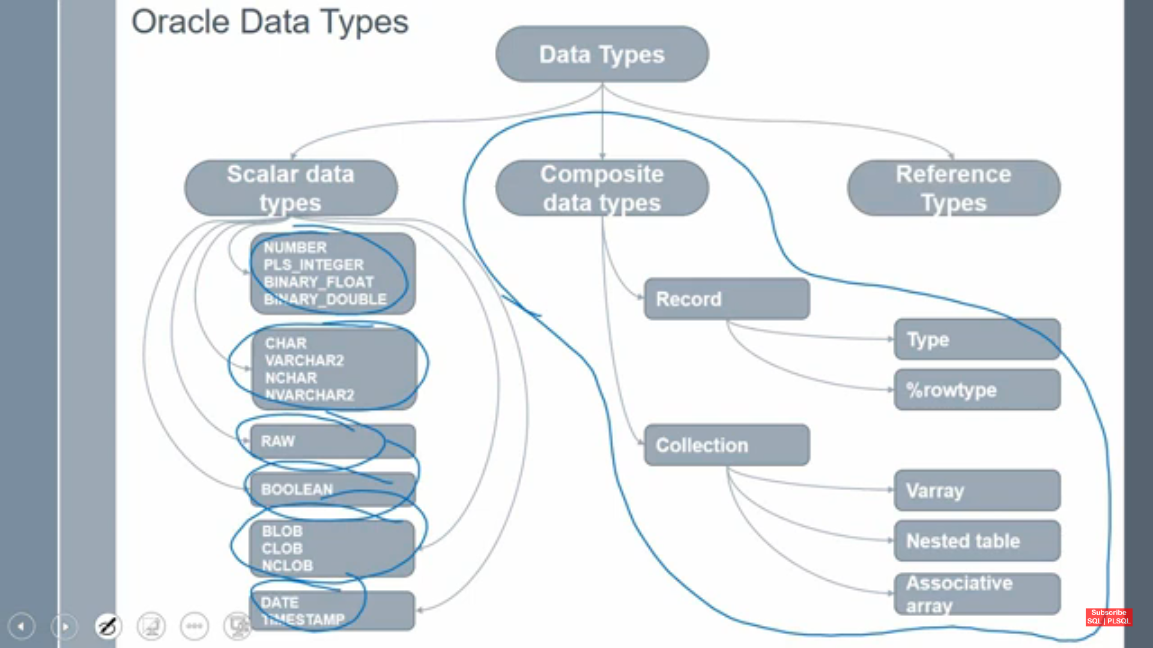

**Record :** Record type that can holds one row of the data-(%type and type both are different) In record can have different datatypes.

**Collection** :- Collection is an ordered group of logically related elements . (collection is similar to array).In collection always have same datatype

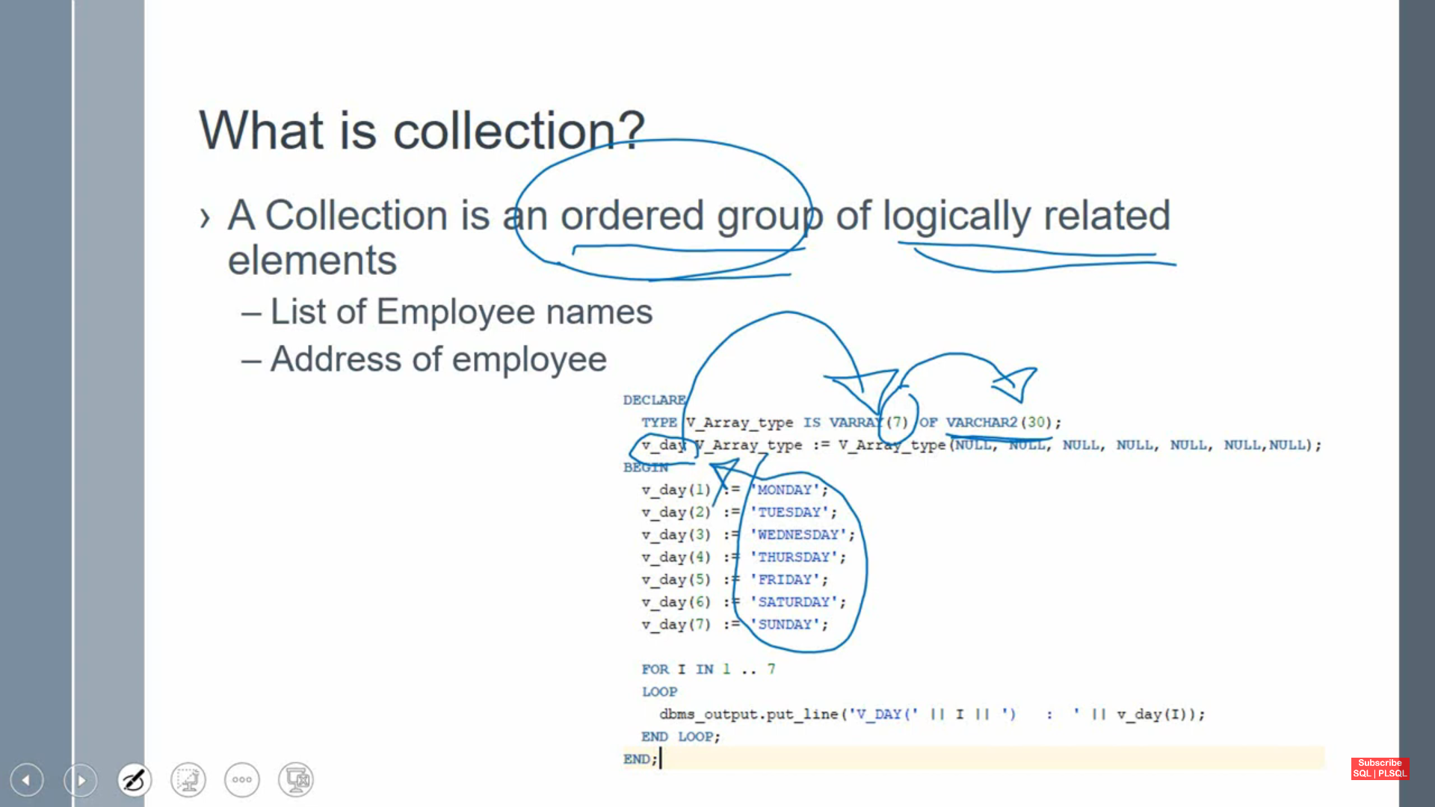

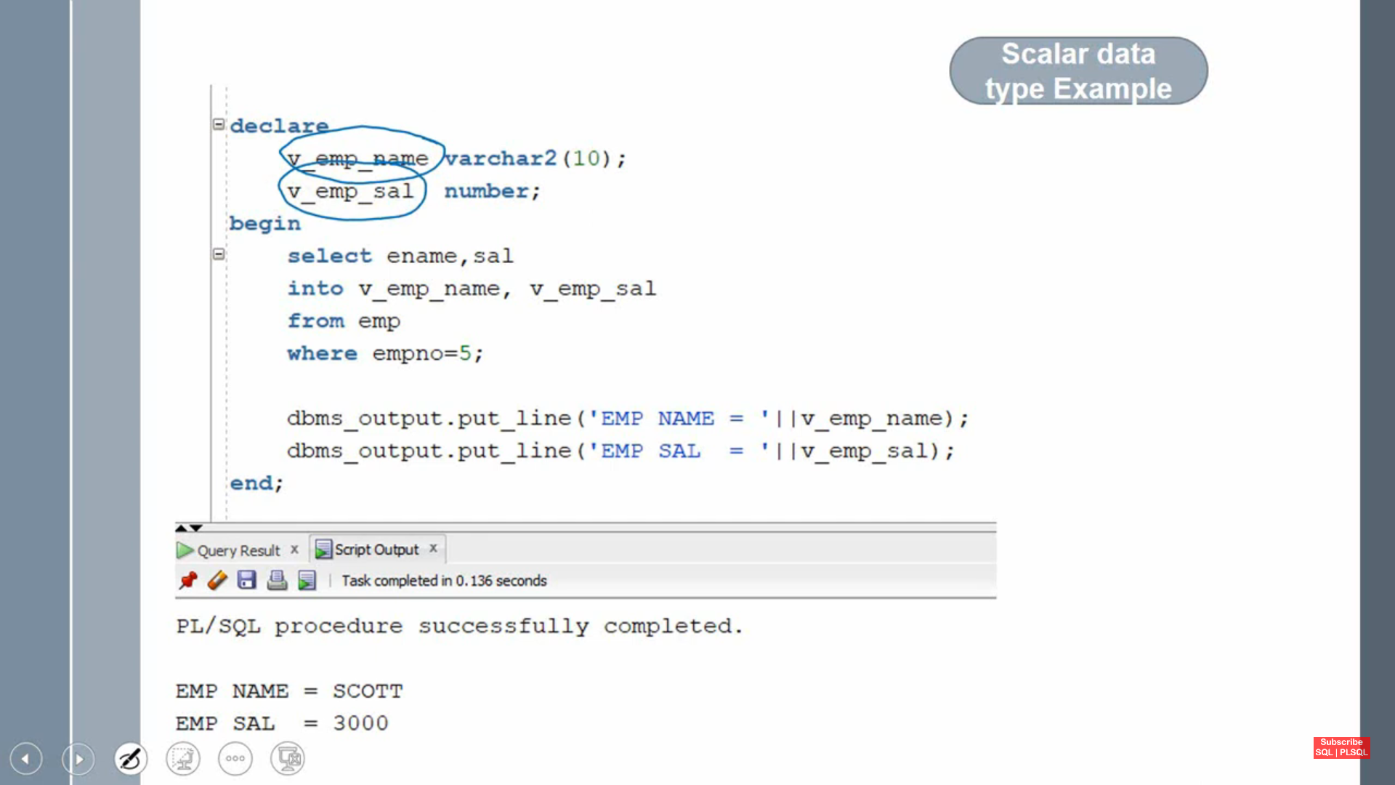

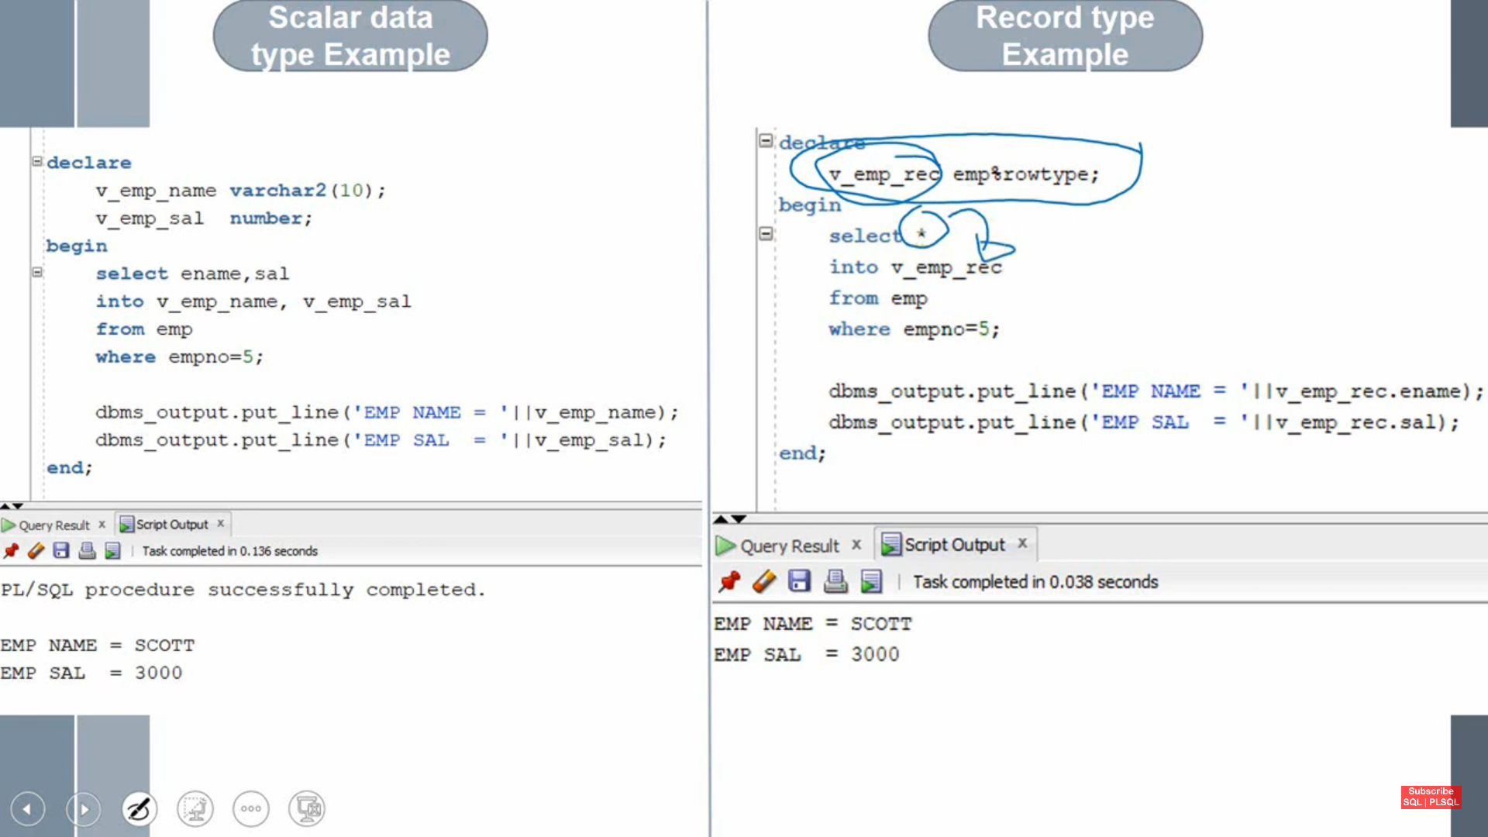

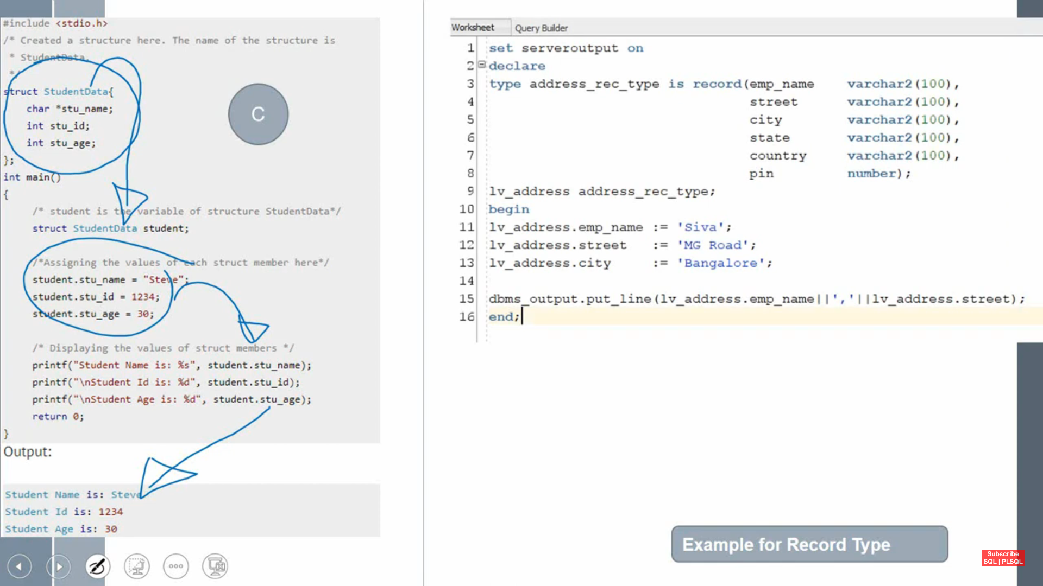

**%rowtype :-it represents one row in a table**

